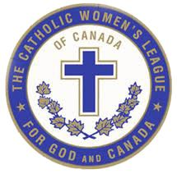
The Catholic Women’s League of Canada

Victoria Diocesan Council Summer Planning Session

July 14, 2018 at St. Mary’s Church Hall
1135 – 4th Avenue, Ladysmith

National Theme: Inspired by the Spirit, Women Respond to God’s Call
Provincial Theme: Leading with Courage
Diocesan Theme: Here I am Lord

AGENDA

10:00 am Opening Reflection in Church

10:15 am Gathering and Refreshments in Hall

10:30 am Review of Agenda and Day’s Objectives

10:45 am Welcome Diocesan Executives and Chairs of Standing Committees
Welcome Parish Council Presidents (or their Designates)

11:00 am Looking at our current Victoria Diocesan CWL
Where are we now?
- What are our strengths
- What are our weaknesses?
- What are our threats?

Noon Lunch Break (please bring bag lunch)

12:30 pm Looking at our Victoria Diocesan CWL’s future
    - What are our opportunities?
    - Where do we want to go?
    - How will we get there?
    - Draft plans for the remainder of 2018 and looking forward to 2019

1:30 pm Discuss 2019 Diocesan and Provincial Conventions
Facilities, Meals, Registration/Credentials, Special Events, Decorations Hospitality/Transportation, Public Relations and Publicity, Liturgy, Treasurer/Budget/Fundraising, Secretary/Printing

2:30 pm Generating Ideas for New Theme to be presented at October Interim meeting

3:00 pm Wrap up

